Task: To Check status of all services

command: service --status-all

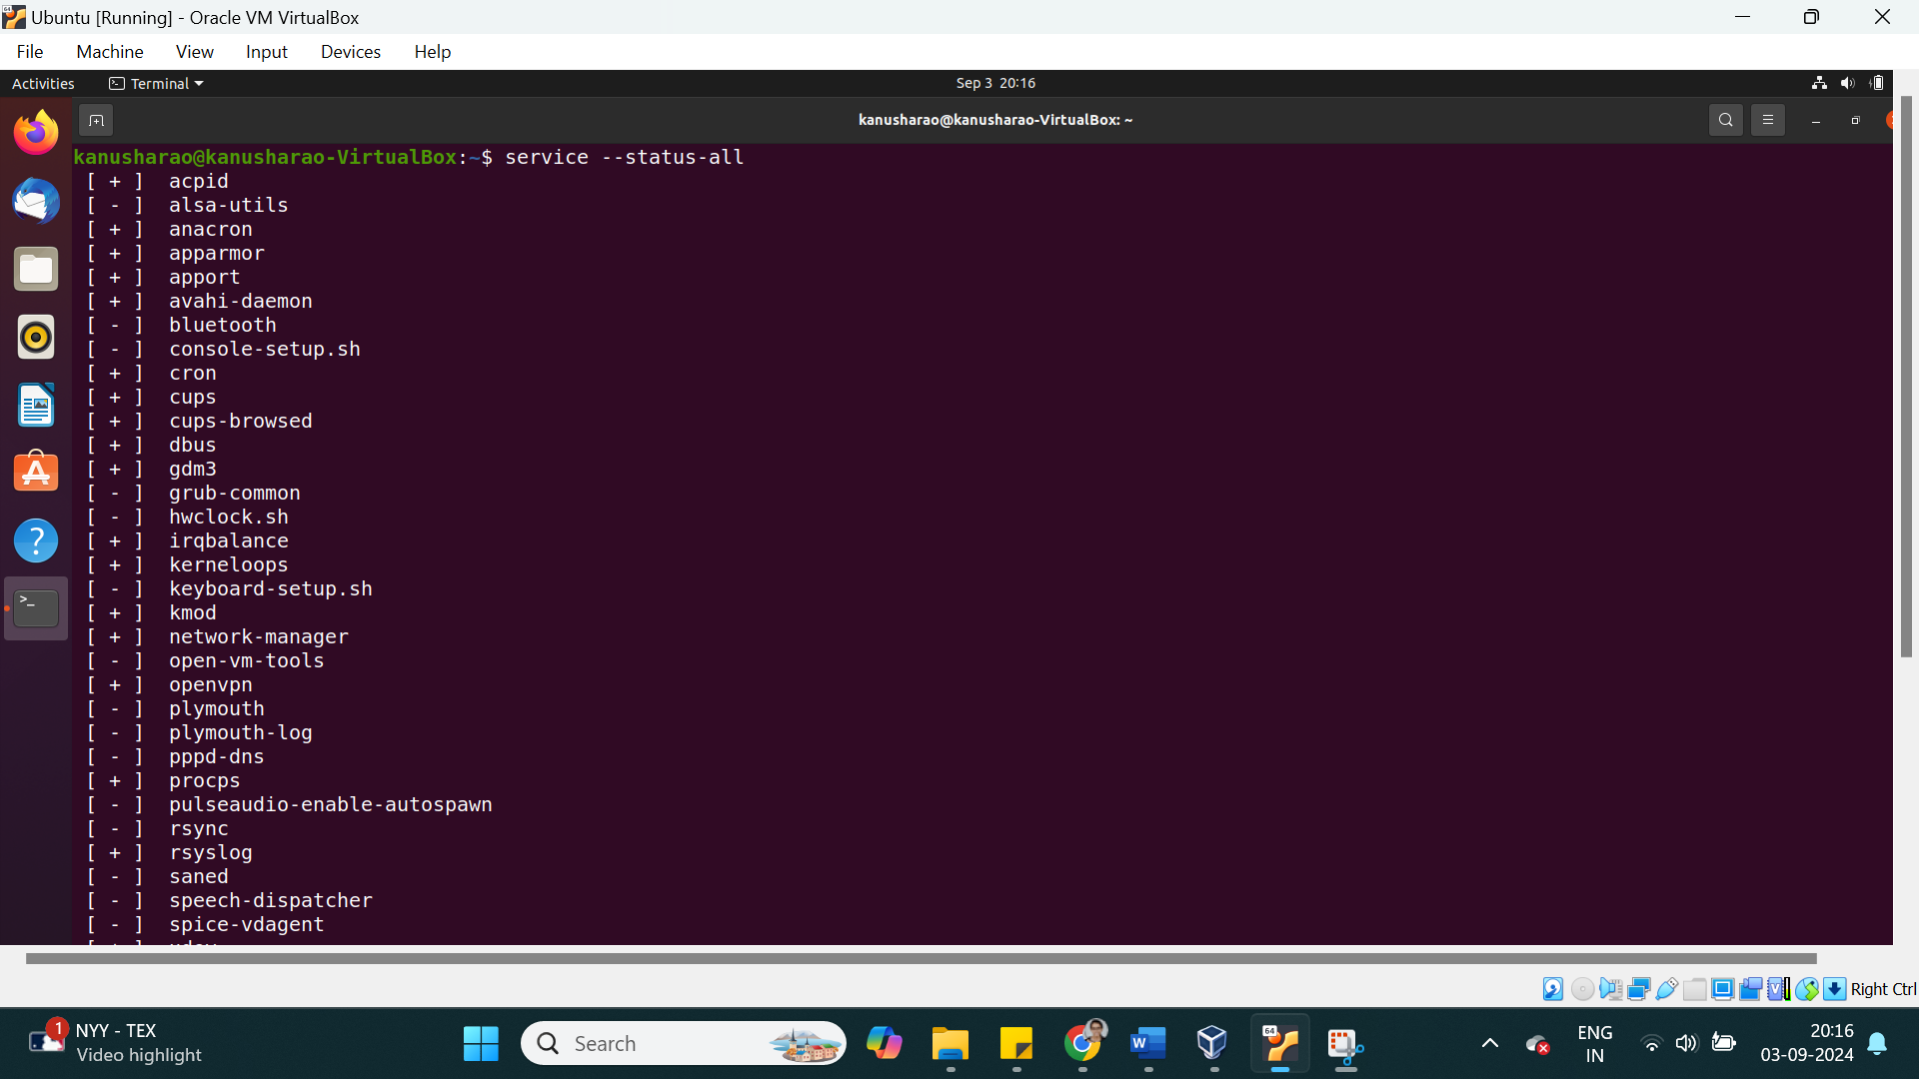

Task: To List all units installed in the file system

command: systemctl -a

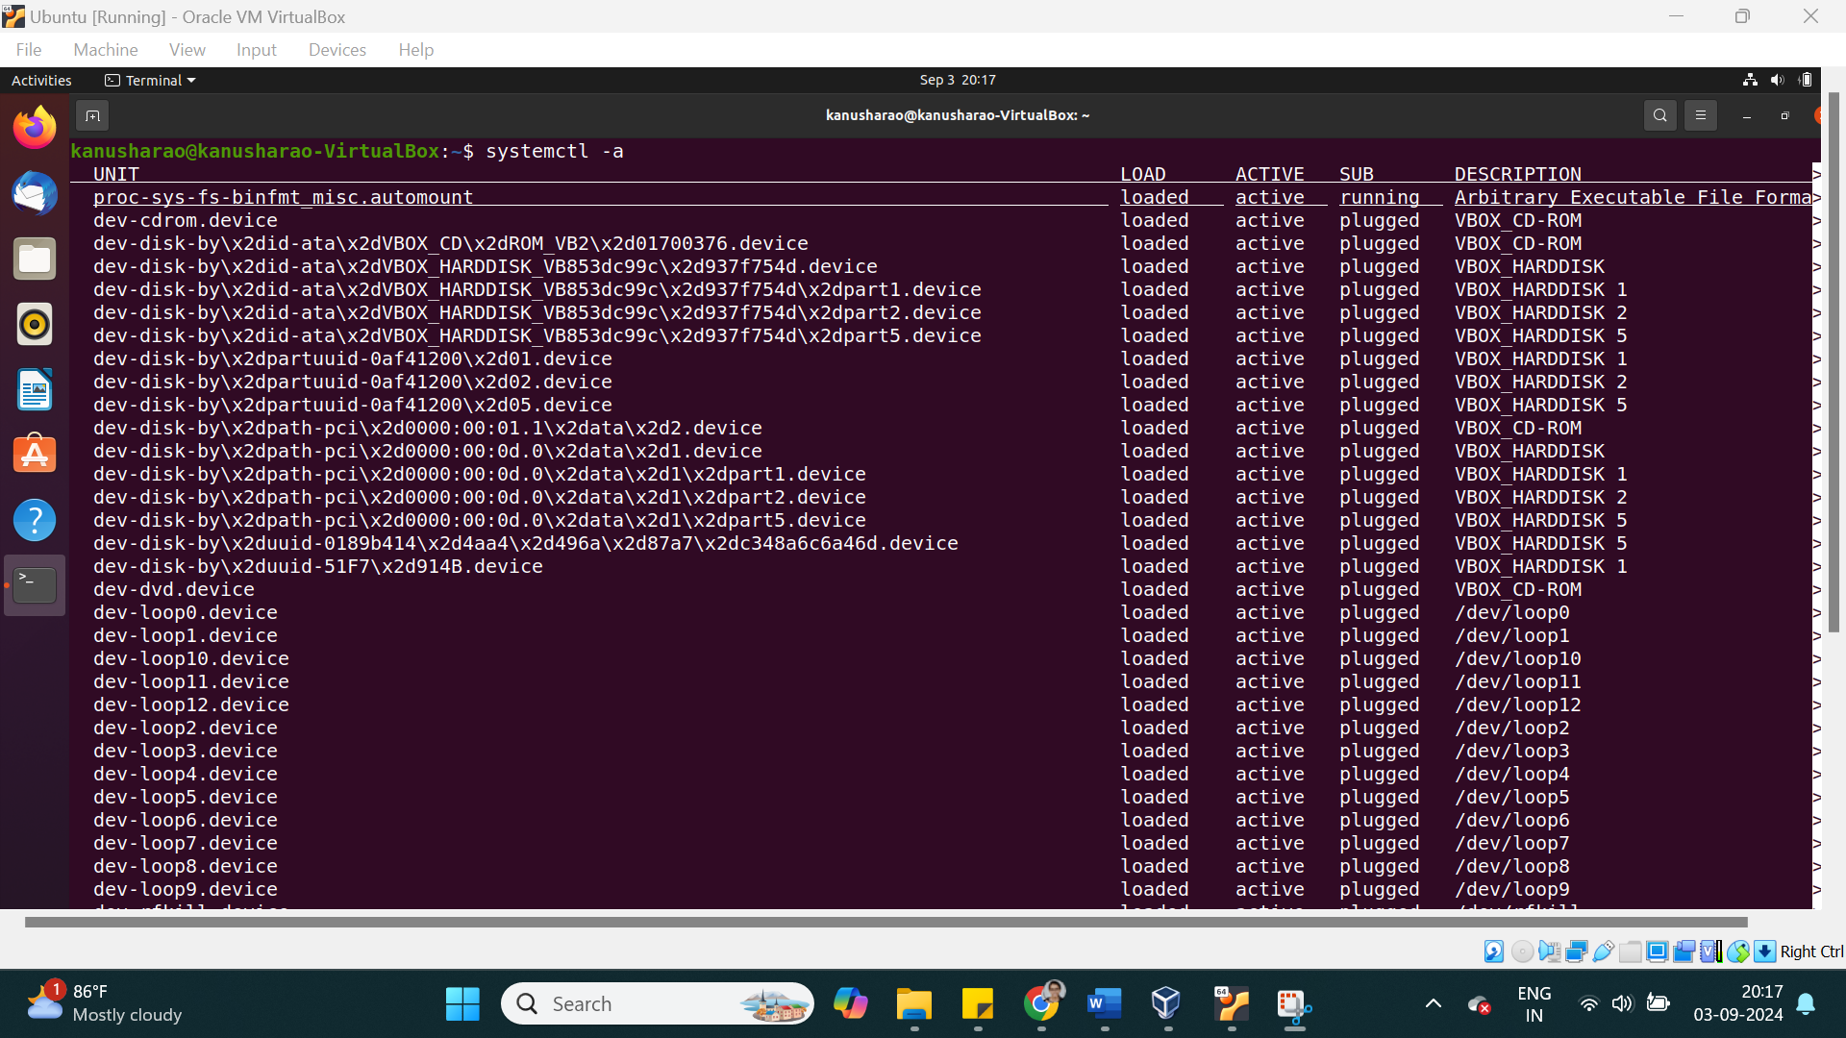

Task: To start a service

command: systemctl start servicename

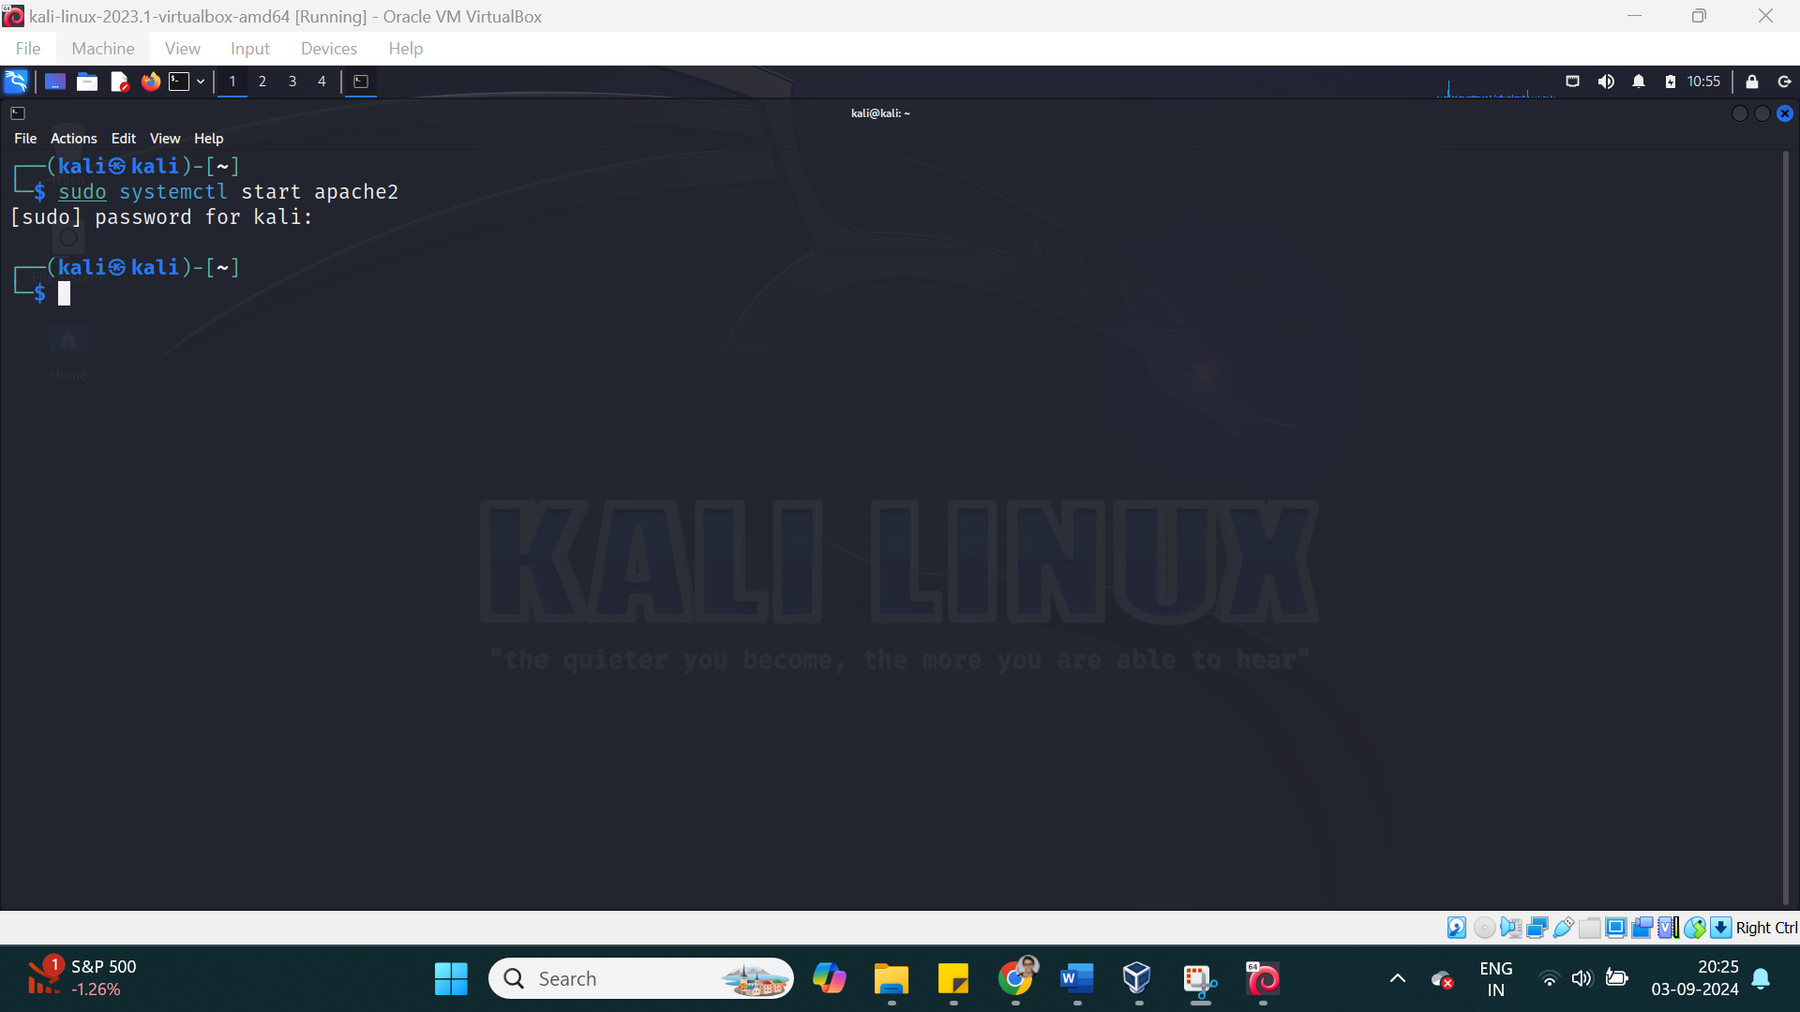

Task: To stop a service

command: systemctl stop servicename

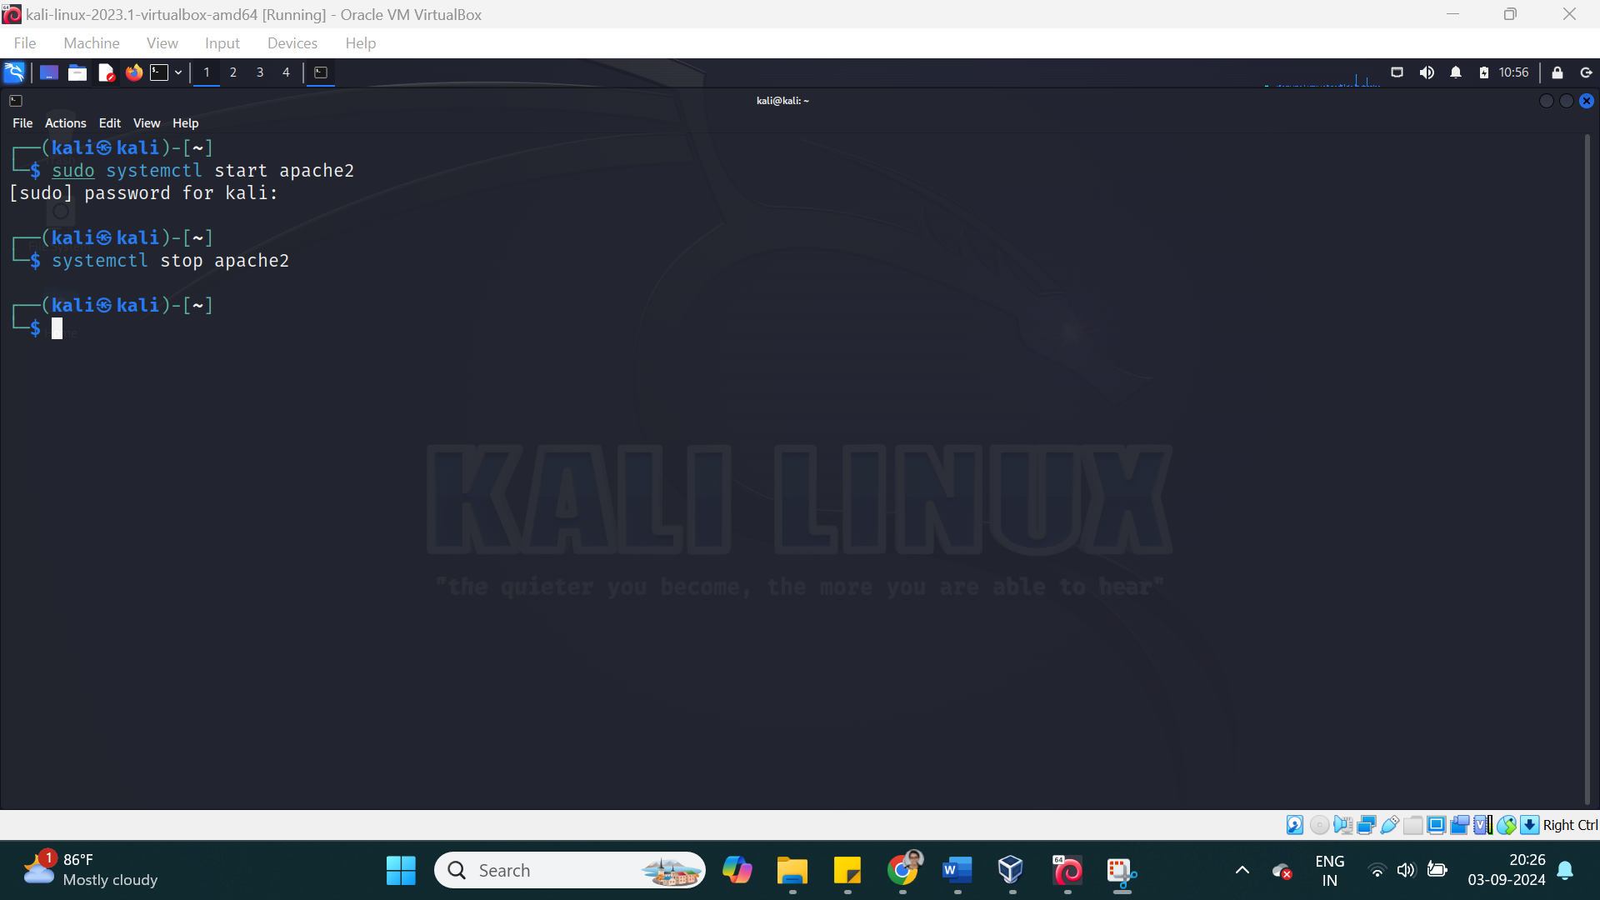

Task: To show the status of a service

command: systemctl status servicename Show

